Welcome to
Trinity Lutheran Church
Lutheran Church—Missouri Synod
A Stephen Ministry Congregation

1354 South Otsego Avenue
Gaylord, Michigan 49735
Church Phone: (989) 732-4816

Church Email: secretary@trinitygaylord.com
www.trinitygaylord.com

Office Hours: Monday through Friday 9am – 1pm

OUR PURPOSE
…is to LOVE GOD, LOVE OTHERS, AND SERVE THE WORLD by worshiping the Lord Jesus, bringing our members into Christ-like maturity, and equipping them through Word and Sacrament for their mission and ministry. We go heart to heart into the world with Jesus, sharing His love, caring for one another, praying, and bringing the lost into a relationship with Christ, by the working of the Holy Spirit.

March 13, 2022
Second Sunday in Lent
Preacher: Rev. Ken Bernthal

ABOUT OUR WORSHIP
We welcome all who gather here today! We are blessed to celebrate together the mercy, grace, and love we have from God through the death and resurrection of our Lord Jesus Christ.

Children: Families with children are very welcome here. Having children in church is important so they can begin to learn about their faith in Jesus, and it’s good for the whole congregation to see. Please feel comfortable keeping “squirmy” kids in the service. This is where they belong, too!

Pew Cards: Guests and Members, please fill out the Guest/Member card located on the back of the pew in front of you and pass it to the end of the aisle. If you forget you can put it in the offering plate on your way out.

If standing is difficult: Please feel free to remain seated during any portion of the service. Please let an Elder or Usher know if you need communion in your pew seat.

About our celebration of Holy Communion: We celebrate the Lord’s Supper in the confession and glad confidence that, as he says, our Lord gives into our mouths not only bread and wine but his very body and blood to eat and to drink for the forgiveness of sins and to strengthen our union with him and with one another. Our Lord invites to his table those who trust his words, repent of all sin, and set aside any refusal to forgive and love as he forgives and loves us, that they may show forth his death until he comes.

Because those who eat and drink our Lord’s body and blood contrary to that which is stated above do so to their great harm, and also because Holy Communion is a confession of the faith which is confessed at this altar. Anyone who is not yet instructed, in doubt, or who hold a confession differing from that of the Lutheran Church—Missouri Synod, and yet desire to receive the sacrament, are asked first to speak with Pastor. Those not communing are still invited to come forward for a blessing from Pastor, and you may indicate this by crossing your arms over your chest.
TTTTTT

GREETING

P Peace be with you.
C And also with you.
T ORDER OF SERVICE T
(The liturgy is from Divine Service Setting four LSB pg. 203ff)

OPENING HYMN
Great Is Thy Faithfulness LSB 809
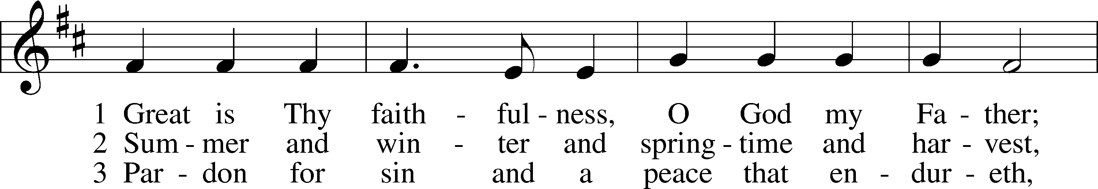
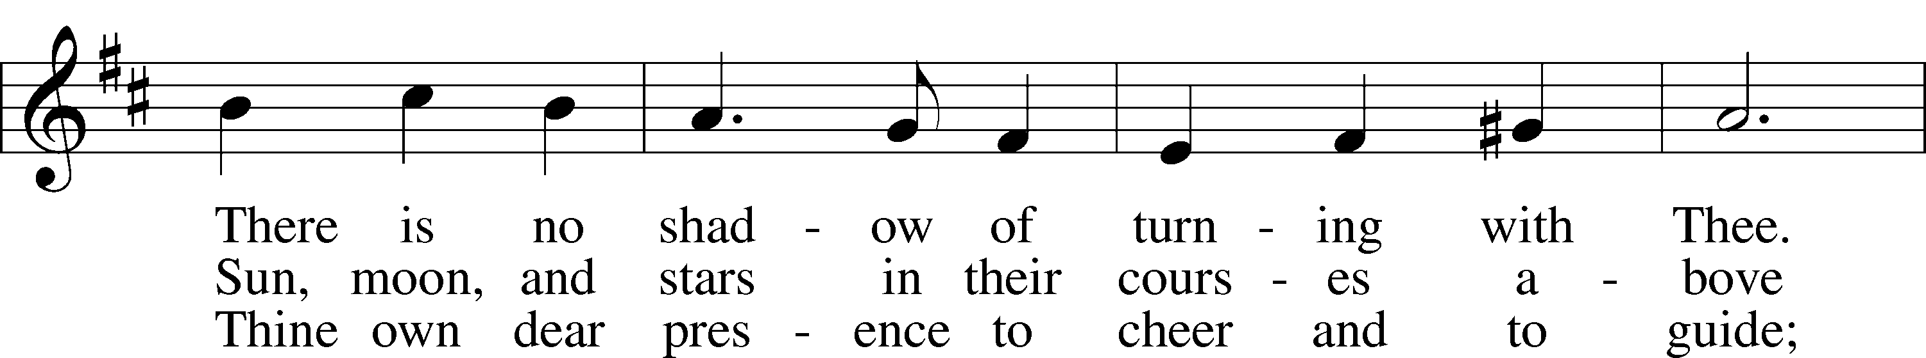
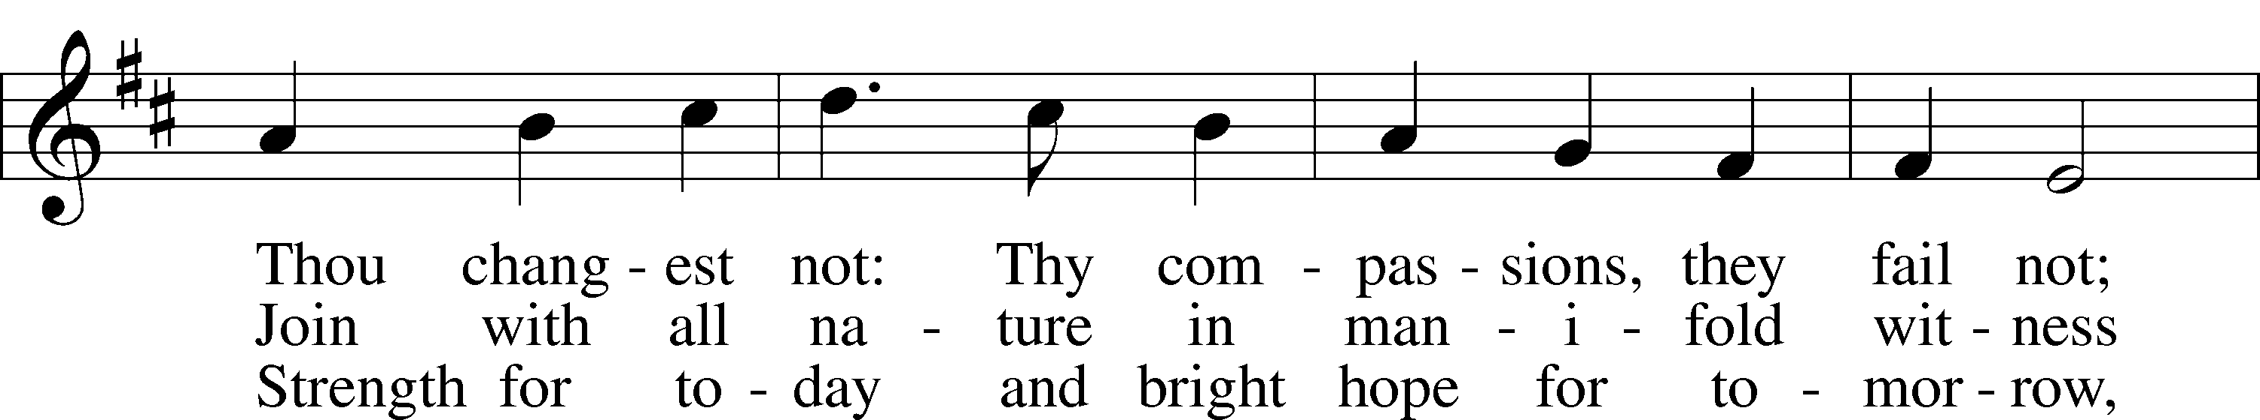
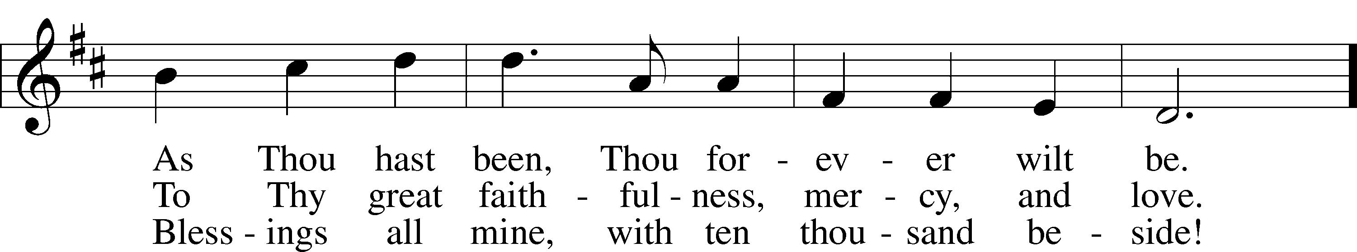
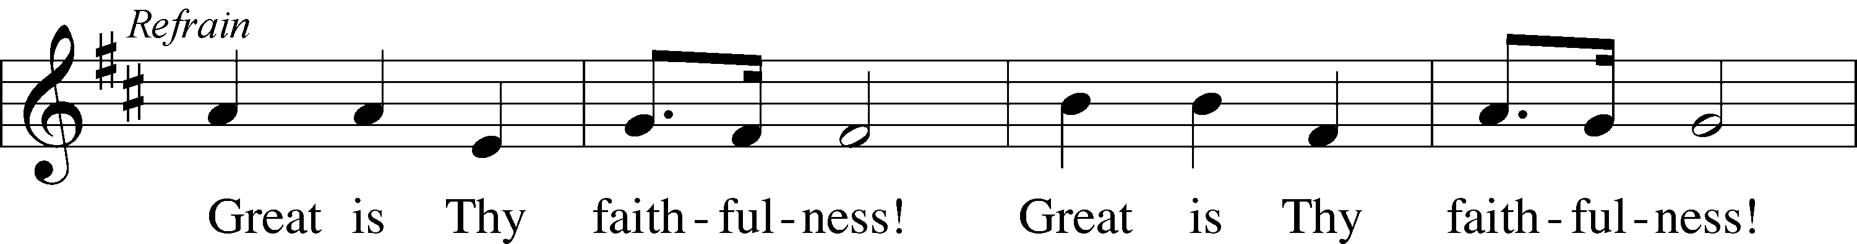
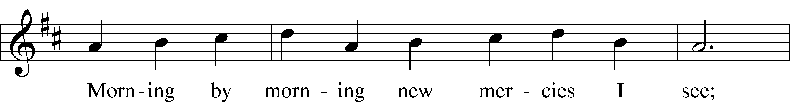
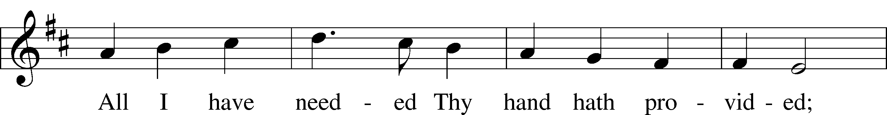
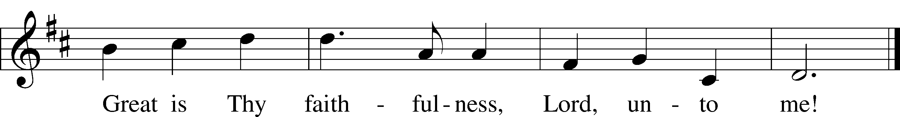
Text: Thomas O. Chisholm, 1866–1960
Tune: William M. Runyan, 1870–1957
Text: Public domain
Tune: Public domain

Please stand as able
CONFESSION and ABSOLUTION
The sign of the cross may be made by all in remembrance of their Baptism.

P In the name of the Father and of the T Son and of the Holy Spirit.
C Amen.
P Our help is in the name of the Lord,
C who made heaven and earth.
P If You, O Lord, kept a record of sins, O Lord, who could stand?
C But with You there is forgiveness; therefore, You are feared.
P Since we are gathered to hear God’s Word, call upon Him in prayer and praise, and receive the body and blood of our Lord Jesus Christ in the fellowship of this altar, let us first consider our unworthiness and confess before God and one another that we have sinned in thought, word, and deed, and that we cannot free ourselves from our sinful condition. Together as His people let us take refuge in the infinite mercy of God, our heavenly Father, seeking His grace for the sake of Christ, and saying: God, be merciful to me, a sinner.
C Almighty God, have mercy upon us, forgive us our sins, and lead us to everlasting life. Amen.
P Almighty God in His mercy has given His Son to die for you and for His sake forgives you all your sins. As a called and ordained servant of Christ, and by His authority, I therefore forgive you all your sins in the name of the Father and of the T Son and of the Holy Spirit.
C Amen.

SERVICE OF THE WORD
INTROIT Psalm 74:1–3; antiphon: Psalm 69:9
P For zeal for your house has consumed me,
and the reproaches of those who reproach you have fallen on me.
C O God, why do you cast us off forever?
Why does your anger smoke against the sheep of your pasture?
P Remember your congregation, which you have purchased of old, which you have redeemed to be the tribe of your heritage!
C Remember Mount Zion, where you have dwelt.
P Direct your steps to the perpetual ruins;
C the enemy has destroyed everything in the sanctuary!
A Glory be to the Father and to the Son
and to the Holy Spirit;
as it was in the beginning,
is now, and will be forever. Amen.
P For zeal for your house has consumed me,
and the reproaches of those who reproach you have fallen on me.

SERVICE OF THE WORD
KYRIE LSB 204
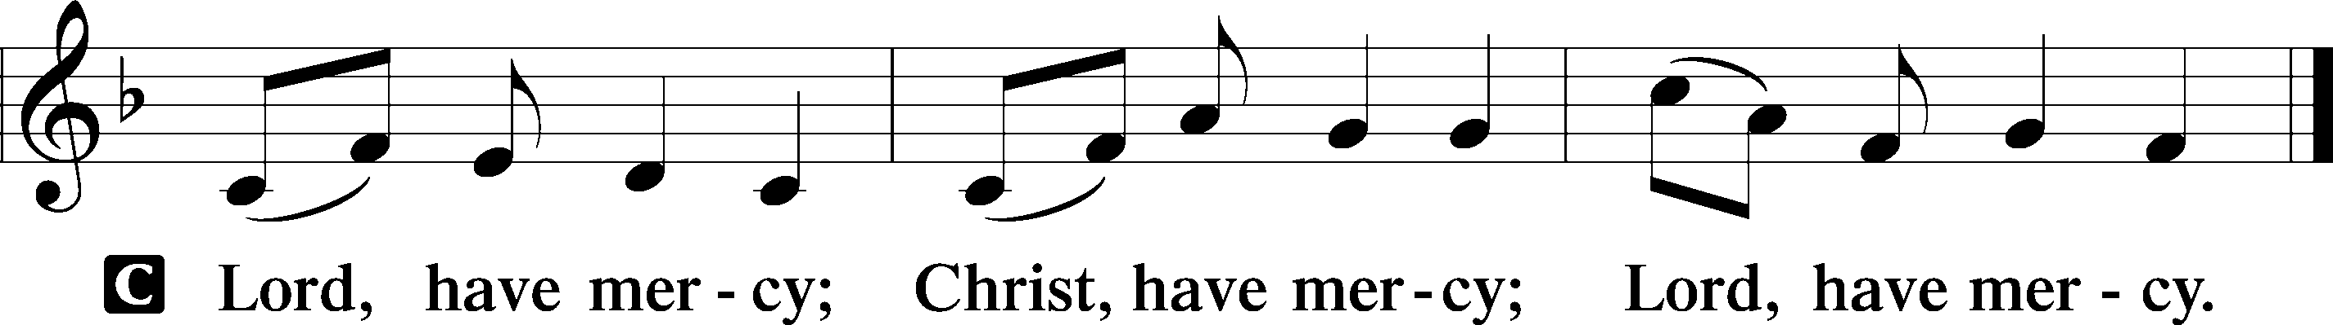

SALUTATION AND COLLECT OF THE DAY
P The Lord be with you.
C And also with you.

P Let us pray.
O God, You see that of ourselves we have no strength. By Your mighty power defend us from all adversities that may happen to the body and from all evil thoughts that may assault and hurt the soul; through Jesus Christ, Your Son, our Lord, who lives and reigns with You and the Holy Spirit, one God, now and forever.
C Amen.

Please be seated

OLD TESTAMENT READING Jeremiah 26:8–15
⁸When Jeremiah had finished speaking all that the Lord had commanded him to speak to all the people, then the priests and the prophets and all the people laid hold of him, saying, “You shall die! ⁹Why have you prophesied in the name of the Lord, saying, ‘This house shall be like Shiloh, and this city shall be desolate, without inhabitant’?” And all the people gathered around Jeremiah in the house of the Lord.
¹⁰When the officials of Judah heard these things, they came up from the king’s house to the house of the Lord and took their seat in the entry of the New Gate of the house of the Lord. ¹¹Then the priests and the prophets said to the officials and to all the people, “This man deserves the sentence of death, because he has prophesied against this city, as you have heard with your own ears.”
¹²Then Jeremiah spoke to all the officials and all the people, saying, “The Lord sent me to prophesy against this house and this city all the words you have heard. ¹³Now therefore mend your ways and your deeds, and obey the voice of the Lord your God, and the Lord will relent of the disaster that he has pronounced against you. ¹⁴But as for me, behold, I am in your hands. Do with me as seems good and right to you. ¹⁵Only know for certain that if you put me to death, you will bring innocent blood upon yourselves and upon this city and its inhabitants, for in truth the Lord sent me to you to speak all these words in your ears.”

P This is the Word of the Lord.
C Thanks be to God.

EPISTLE Philippians 3:17—4:1
¹⁷Brothers, join in imitating me, and keep your eyes on those who walk according to the example you have in us. ¹⁸For many, of whom I have often told you and now tell you even with tears, walk as enemies of the cross of Christ. ¹⁹Their end is destruction, their god is their belly, and they glory in their shame, with minds set on earthly things. ²⁰But our citizenship is in heaven, and from it we await a Savior, the Lord Jesus Christ, ²¹who will transform our lowly body to be like his glorious body, by the power that enables him even to subject all things to himself.
¹Therefore, my brothers, whom I love and long for, my joy and crown, stand firm thus in the Lord, my beloved.

P This is the Word of the Lord.
C Thanks be to God.

Please stand as able

HOLY GOSPEL Luke 13:31–35
P The Holy Gospel according to St. Luke, the thirteenth chapter.
C Glory to You, O Lord.

³¹At that very hour some Pharisees came and said to [Jesus], “Get away from here, for Herod wants to kill you.” ³²And he said to them, “Go and tell that fox, ‘Behold, I cast out demons and perform cures today and tomorrow, and the third day I finish my course. ³³Nevertheless, I must go on my way today and tomorrow and the day following, for it cannot be that a prophet should perish away from Jerusalem.’ ³⁴O Jerusalem, Jerusalem, the city that kills the prophets and stones those who are sent to it! How often would I have gathered your children together as a hen gathers her brood under her wings, and you would not! ³⁵Behold, your house is forsaken. And I tell you, you will not see me until you say, ‘Blessed is he who comes in the name of the Lord!’”

P This is the Gospel of the Lord.
C Praise to You, O Christ.

NICENE CREED
C I believe in one God,
the Father Almighty,
maker of heaven and earth
and of all things visible and invisible.
And in one Lord Jesus Christ,
the only-begotten Son of God,
begotten of His Father before all worlds,
God of God, Light of Light,
very God of very God,
begotten, not made,
being of one substance with the Father,
by whom all things were made;
who for us men and for our salvation came down from heaven
and was incarnate by the Holy Spirit of the virgin Mary
and was made man;
and was crucified also for us under Pontius Pilate.
He suffered and was buried.
And the third day He rose again according to the Scriptures
and ascended into heaven
and sits at the right hand of the Father.
And He will come again with glory to judge both the living and the dead,
whose kingdom will have no end.
And I believe in the Holy Spirit,
the Lord and giver of life,
who proceeds from the Father and the Son,
who with the Father and the Son together is worshiped and glorified,
who spoke by the prophets.
And I believe in one holy Christian and apostolic Church,
I acknowledge one Baptism for the remission of sins,
and I look for the resurrection of the dead
and the life T of the world to come. Amen.

Please be seated

ALL GOD’S CHILDREN – TALK

HYMN OF THE DAY
Lord, Keep Us Steadfast in Your Word LSB 655
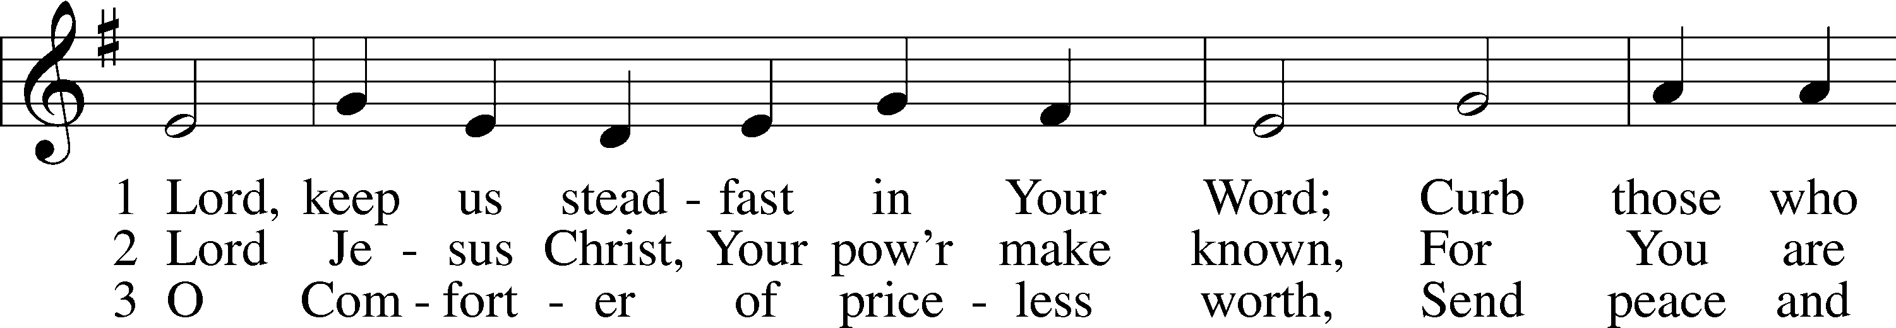
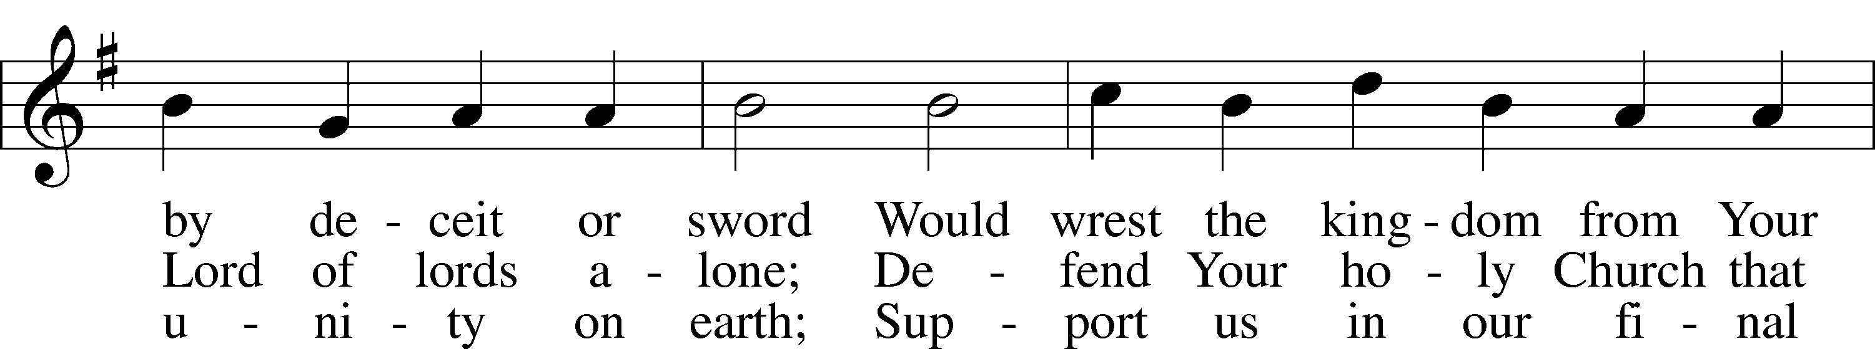
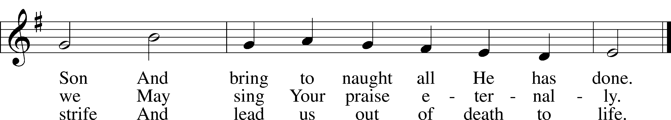
Text: Martin Luther, 1483–1546; tr. Catherine Winkworth, 1827–78, alt.
Tune: Geistliche Lieder auffs new gebessert, 1543, Wittenberg, ed. Joseph Klug
Text and tune: Public domain

SERMON
Please stand as able

PRAYER of the CHURCH
After each Segment:
P Lord, in Your Mercy,
C Hear our Prayer.
After Final Segment:
P Hear us as we pray in His name and as He has taught us:
LORD’S PRAYER
C Our Father who art in heaven,
hallowed be Thy name,
Thy kingdom come,
Thy will be done on earth
as it is in heaven;
give us this day our daily bread;
and forgive us our trespasses
as we forgive those
who trespass against us;
and lead us not into temptation,
but deliver us from evil.
For Thine is the kingdom
and the power and the glory
forever and ever. Amen.

SERVICE of the SACRAMENT

PREFACE LSB 208
P The Lord be with you.
C And also with you.
P Lift up your hearts.
C We lift them to the Lord.
P Let us give thanks to the Lord our God.
C It is right to give Him thanks and praise.
P It is truly good, right, and salutary that we should at all times and in all places give thanks to You, O Lord, holy Father, almighty and everlasting God, for the countless blessings You so freely bestow on us and all creation. Above all, we give thanks for Your boundless love shown to us when You sent Your only-begotten Son, Jesus Christ, into our flesh and laid on Him our sin, giving Him into death that we might not die eternally. Because He is now risen from the dead and lives and reigns to all eternity, all who believe in Him will overcome sin and death and will rise again to new life. Therefore with angels and archangels and with all the company of heaven we laud and magnify Your glorious name, evermore praising You and singing:

SANCTUS LSB 208
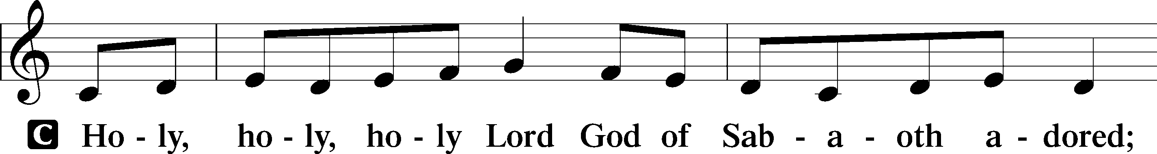
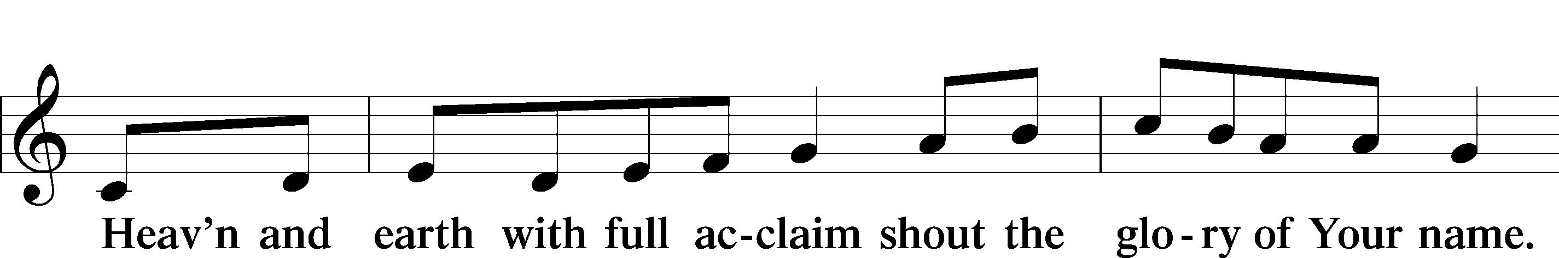
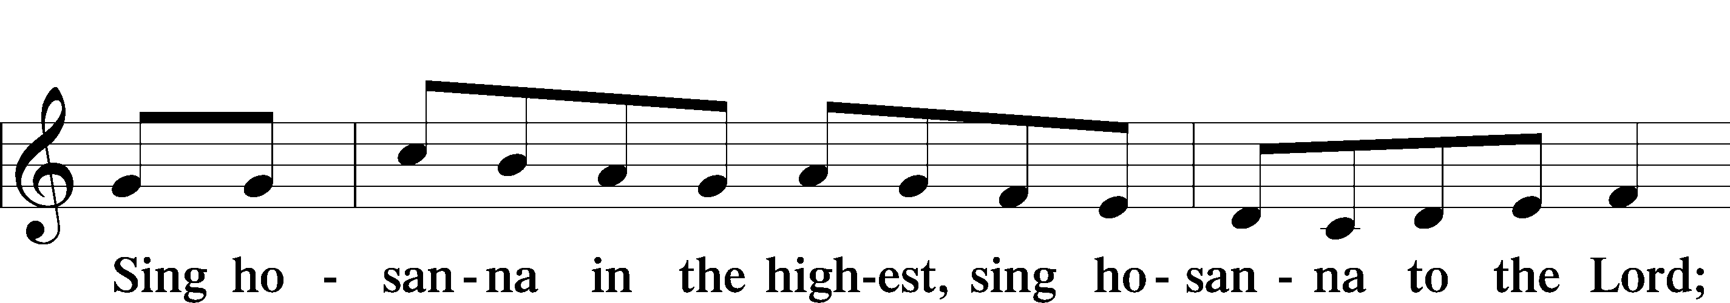

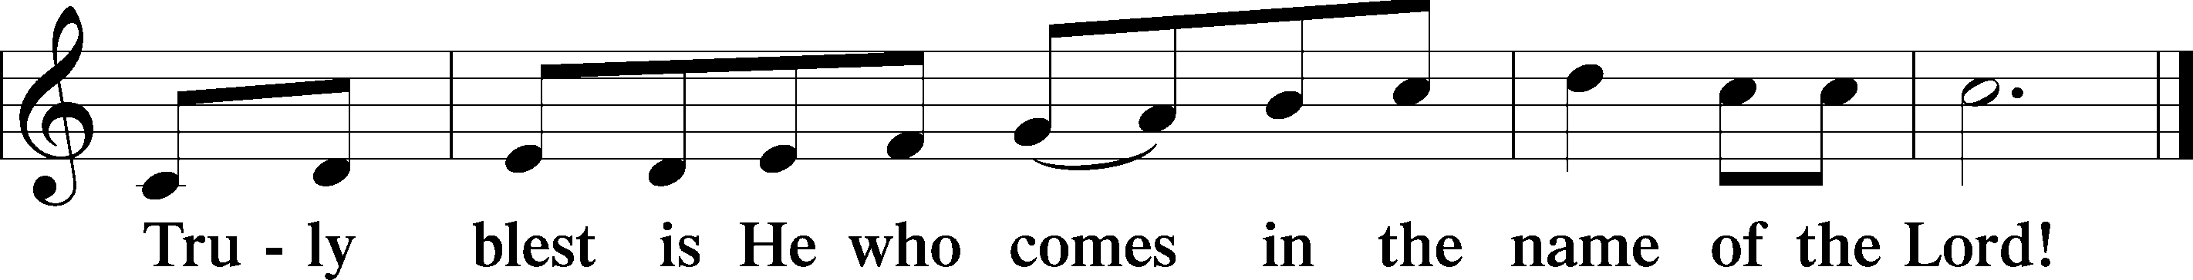

PRAYER OF THANKSGIVING
P Blessed are You, O Lord our God, king of all creation, for You have had mercy on us and given Your only-begotten Son that whoever believes in Him should not perish but have eternal life.

As the glory of Your presence once filled Your ancient temple, so in the incarnation of Your Son, Jesus Christ, You manifested the fullness of Your glory in human flesh.

We give You thanks that in His most Holy Supper You reveal Your glory to us. Grant us faithfully to eat His body and drink His blood so that we may one day behold Your glory face to face.

THE WORDS OF OUR LORD
P Our Lord Jesus Christ, on the night when He was betrayed, took bread, and when He had given thanks, He broke it and gave it to the disciples and said: “Take, eat; this is My T body, which is given for you. This do in remembrance of Me.”
In the same way also, He took the cup after supper, and when He had given thanks, He gave it to them, saying: “Drink of it, all of you; this cup is the New Testament in My T blood, which is shed for you for the forgiveness of sins. This do, as often as you drink it, in remembrance of Me.”

PAX DOMINI
P The peace of the Lord be with you always.
C Amen.
AGNUS DEI
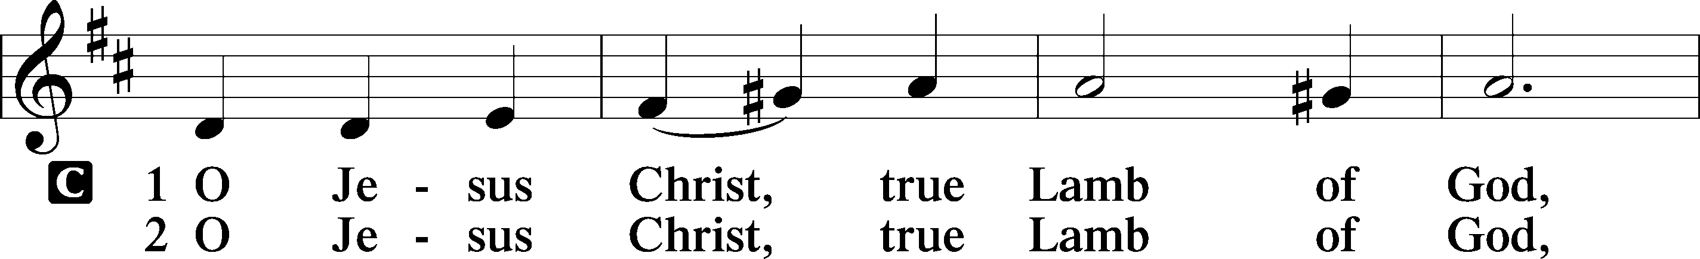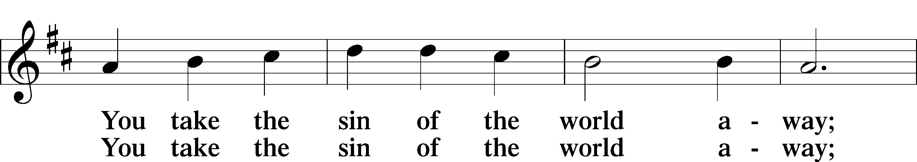
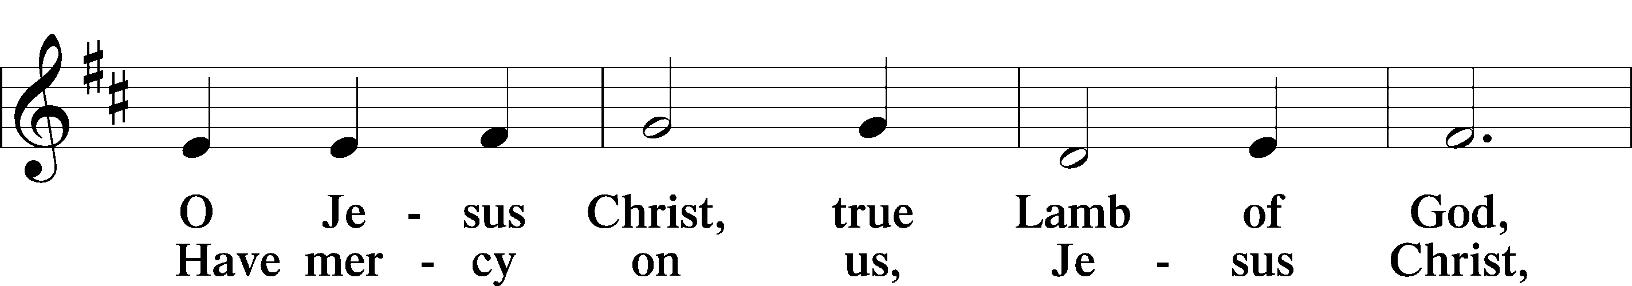
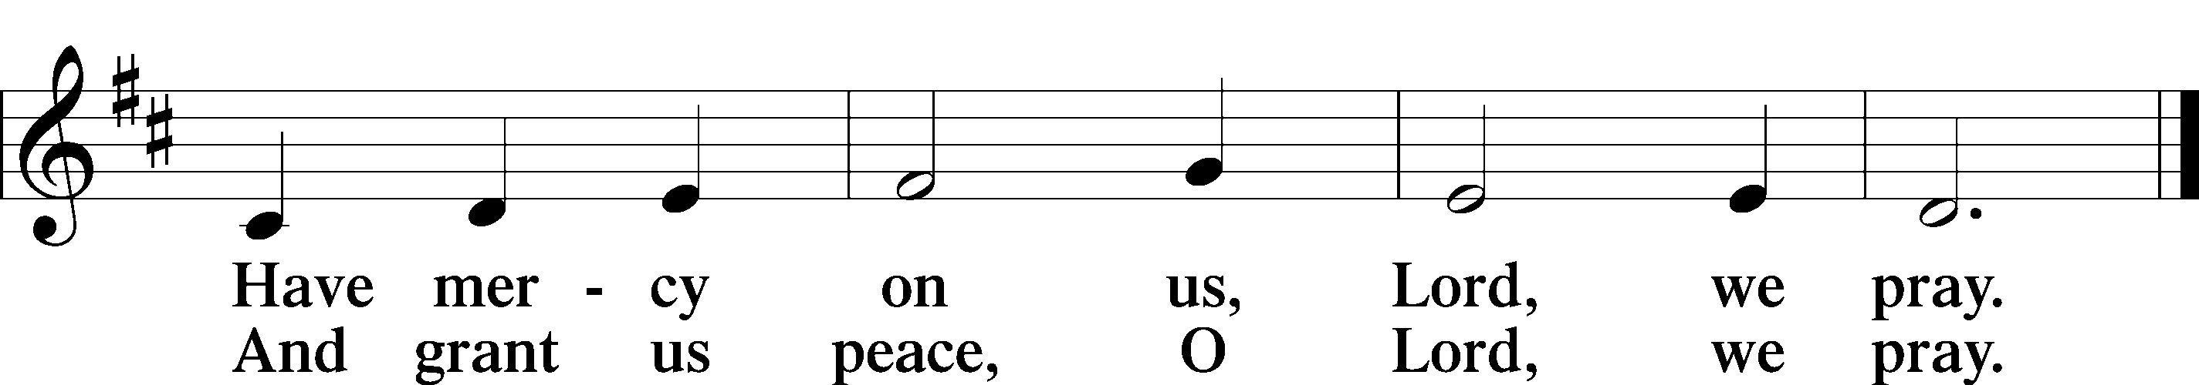

Please be seated
DISTRIBUTION
The pastor and those who assist him receive the body and blood of Christ first, then Communion will be served in a continuous fashion. Households may commune at the same time together. Ushers will help direct you forward via the center aisle; please return to your seats via the side aisles. Gluten-free bread is available for those who need it, as is non-alcoholic grape juice. Simply request either when you come forward to receive Communion.
DISTRIBUTION HYMN
The Church’s One Foundation LSB 644 sts. 1–5
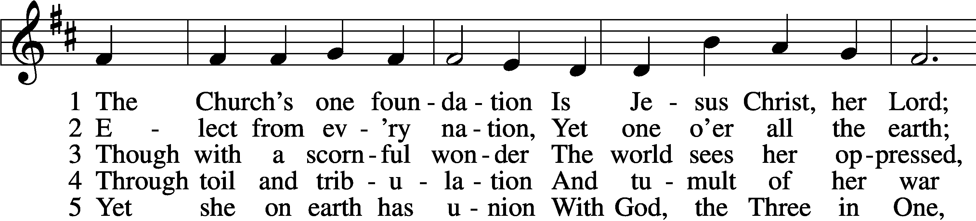
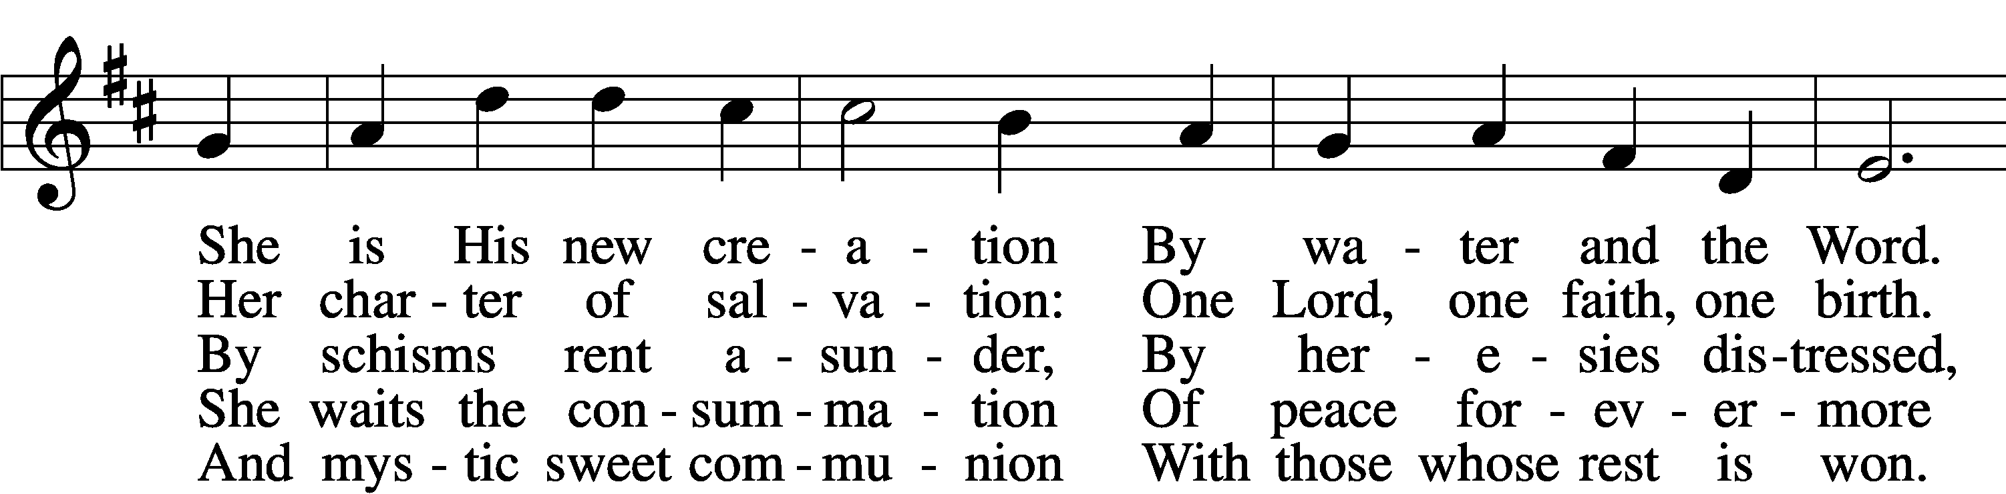
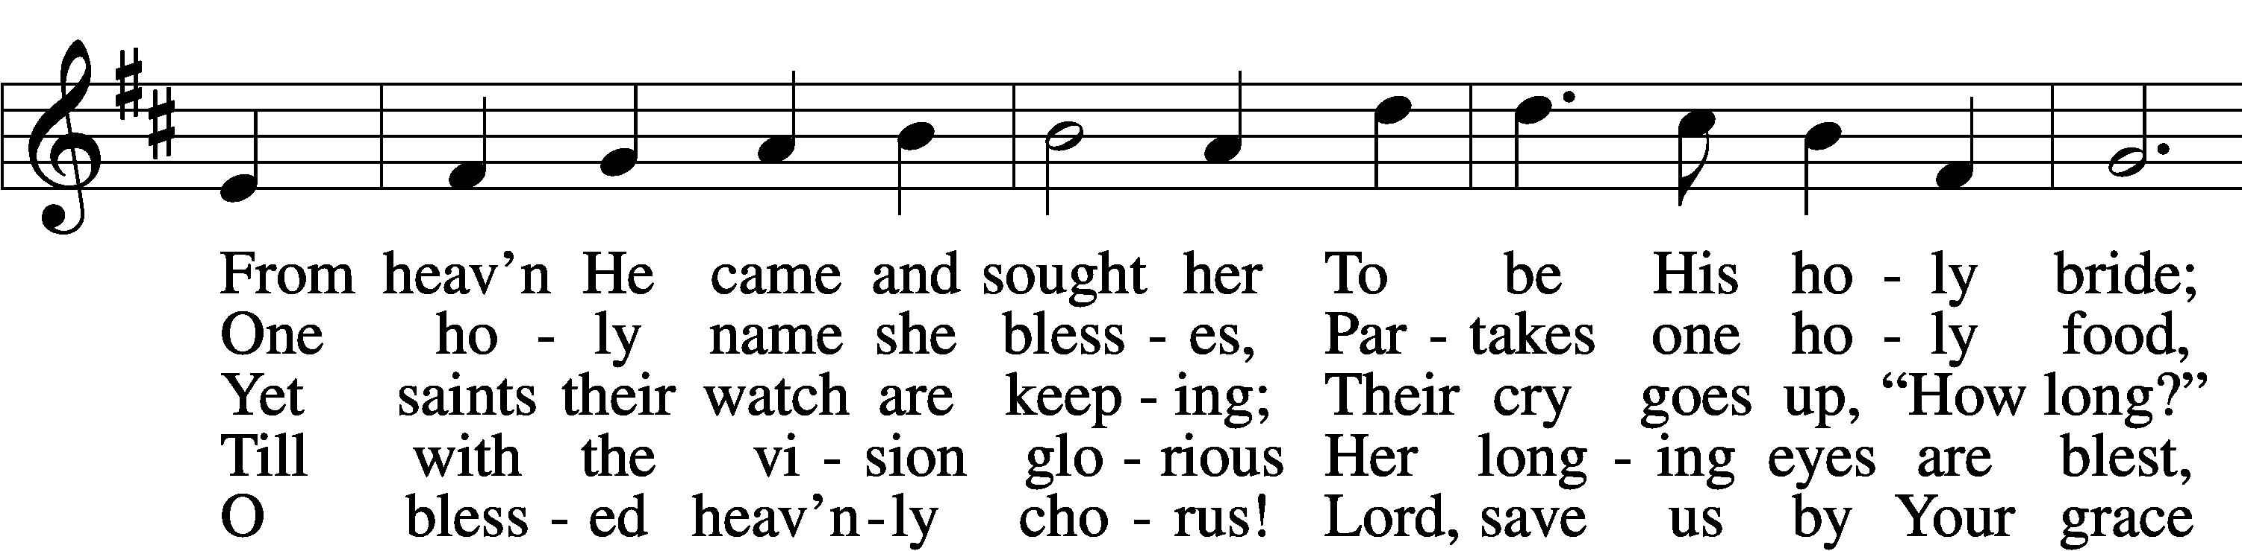
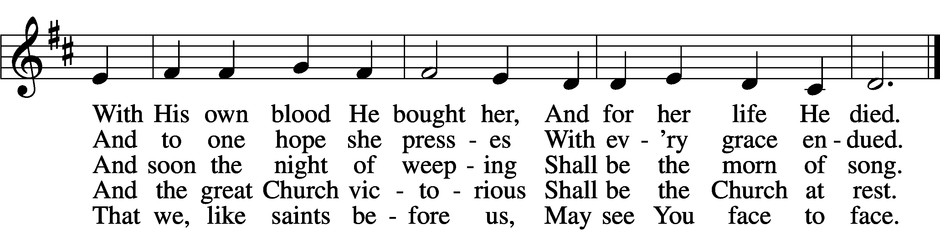

Text: Samuel J. Stone, 1839–1900, alt.
Tune: Samuel S. Wesley, 1810–76
Text and tune: Public domain

Please stand as able

THE DISMISSAL
P The body and blood of our Lord Jesus Christ strengthen and preserve you in body and soul
to life everlasting. Depart T in peace.
C Amen.

NUNC DIMITTIS LSB 211
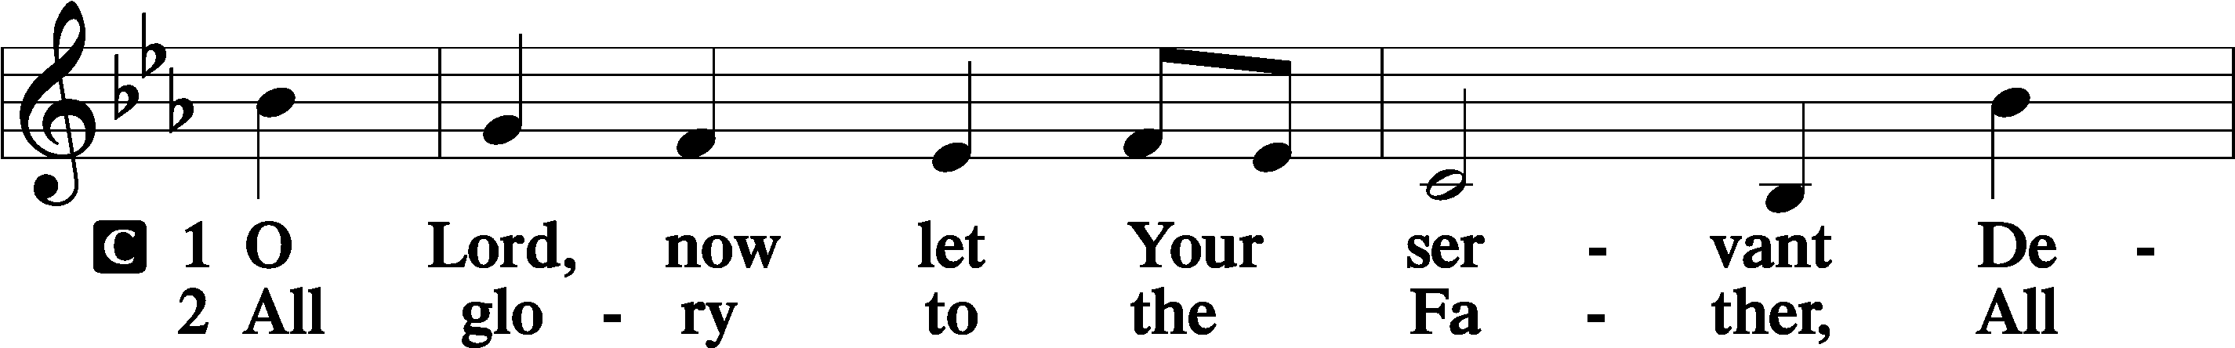
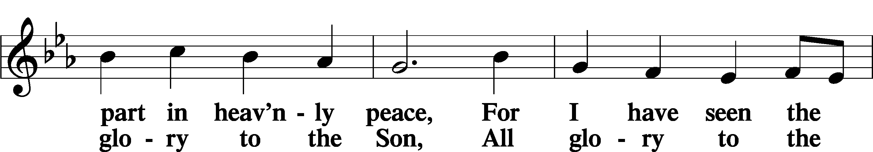
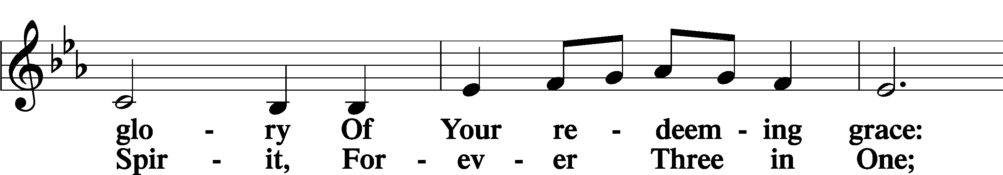
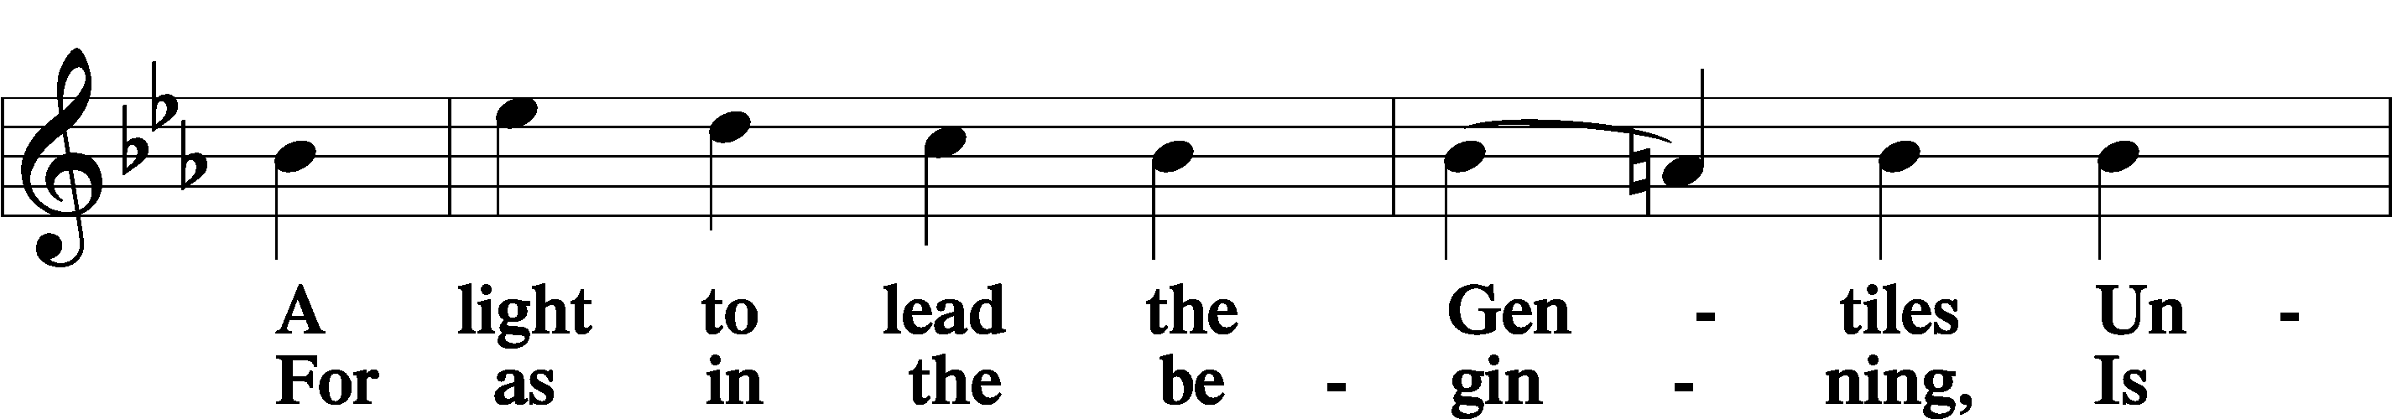
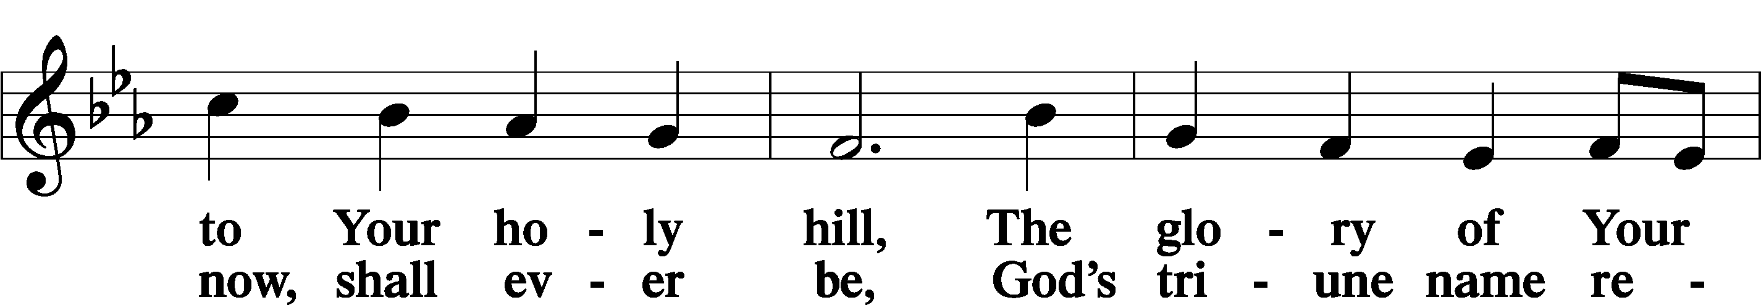
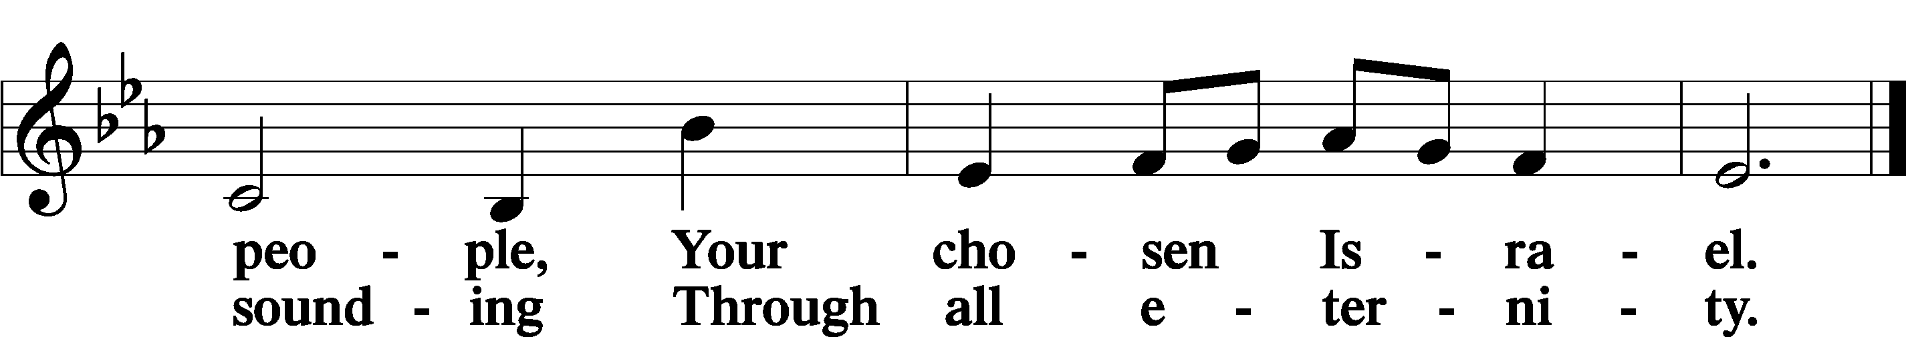

POST COMMUNION COLLECT
P Let us pray.
We give thanks to You, almighty God, that You have refreshed us through this salutary gift, and we implore You that of Your mercy You would strengthen us through the same in faith toward You and in fervent love toward one another; through Jesus Christ, Your Son, our Lord, who lives and reigns with You and the Holy Spirit, one God, now and forever.
C Amen.
BENEDICAMUS LSB 212
P Let us bless the Lord.
C Thanks be to God.
BENEDICTION
P The Lord bless you and keep you.
The Lord make His face shine on you and be gracious to you.
The Lord look upon you with favor and T give you peace.
C Amen.

Please be seated
CLOSING HYMN
Christ Be My Leader LSB 861
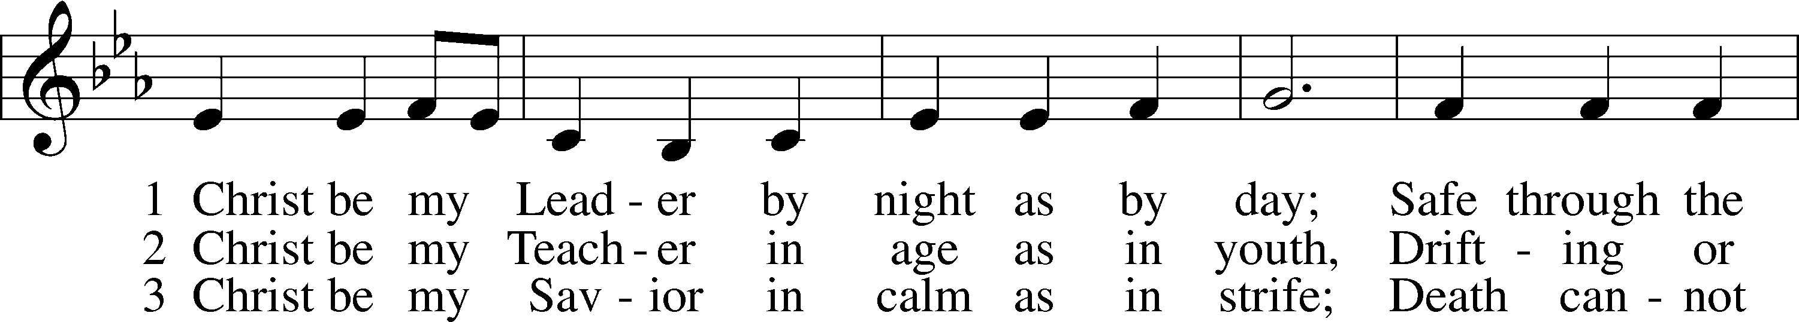
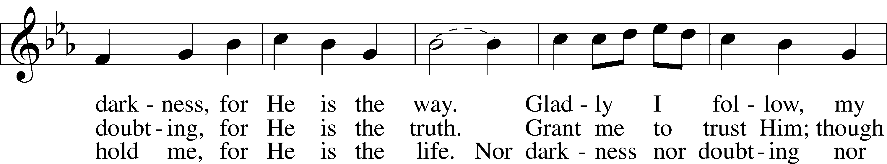
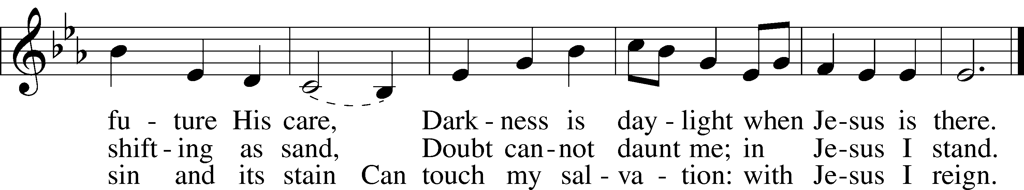
Text: Timothy Dudley-Smith, 1926 Tune: Irish Text: © 1964, renewed 1992 Hope Publishing Co. Used by permission: LSB Hymn License no. 110002537 Tune: Public domain
ANNOUNCEMENTS and SENDING WORDS
P We go to live for Jesus!
C We go to share His love!

Acknowledgments
Unless otherwise indicated, Scripture quotations are from the ESV® Bible (The Holy Bible, English Standard Version®), copyright © 2001 by Crossway, a publishing ministry of Good News Publishers. Used by permission. All rights reserved. Created by Lutheran Service Builde

Next Week’s Readings
Old Testament: Eaekiel 33:7-20
Epistle: 1 Cotinthians 10:1-13
Holy Gospel: Luke 13:1-9

SERVING in GODS HOUSE TODAY
Pastor: Rev. Ken Bernthal
Elder: Wally Beasinger, Dave Beyers
Ushers: Wally & Pam Beasinger
Greeters: Wally & Pam Beasinger
Coffee LWML
Counters: Sandra Smith, Sharon Kwapis
Altar Care: Terri Raithel
Piano/Organist: Tom & Jean Beach
Children’s Talk: Nancy Ely
BIRTHDAYS
3/13 Brady Beyers
3/14 Abbie Trahin

ANNIVERSARIES
3/14 Brian & Denise Rood
3/17 Greg & Sharon Techel

